Fragile Environment – Animal Population Growth and Decay

Match up the description of the animal population change and the formula.
Be warned some are wrong of pairs are incorrect – can you write a correct match?

Population of seals declines at 10% per year for two years | 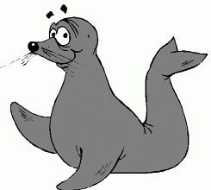 | n x 1.03¹⁰
Population of turtles grows at 10% per year for two years |  | n x 0.99³
Population of sharks declines at 1% per year for two years |  | n x 1.1²
Population of wolves declines at 1% per year for three years | 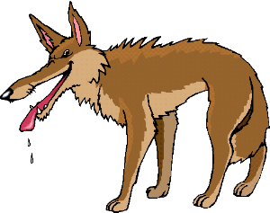 | n x 1.02¹⁰
Population of bears grows at 1% per year for two years |  | n x 0.99²
Population of elephants grows at 1% per year for three years |  | n x 0.98¹⁰
Population of fish grows at 2% per year for ten years |  | n x 0.9²
Population of frogs grows at 3% per year for ten years |  | n x 1.01²
Population of giraffes declines at 2% per year for ten years |  | n x 1.1¹⁰
Population of rhinos declines by 3% per year for two years | 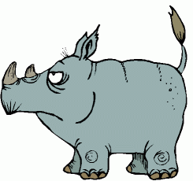 | n x 1.2³
Population of zebras grows by 2% per year for three years |  | n x 1.01³
Population of snakes declines by 10% per year for ten years |  | n x 0.97²

If n was the same in each formula, can you put the formulae in order without using a calculator?

